Polygonal Cross Sections

Definition
# Source: AI Source: Provided by: [Data Path: Persons Table -> ID Column: 1, Name_En Column: Motasem Essam] -> From: [ChatGPT] on [7/25/2026]
A Polygonal Cross Section is a two-dimensional polygonal region formed when a plane intersects a solid and the resulting boundary consists entirely of straight-line segments.
The resulting polygon may have three or more sides, depending on the solid's geometry and the position and orientation of the cutting plane.
Polygonal cross sections commonly occur in polyhedra, such as cubes, prisms, pyramids, and other solids with flat polygonal faces.

Geometric Representation
# Source: AI Source: Provided by: [Data Path: Persons Table -> ID Column: 1, Name_En Column: Motasem Essam] -> From: [ChatGPT] on [7/25/2026]
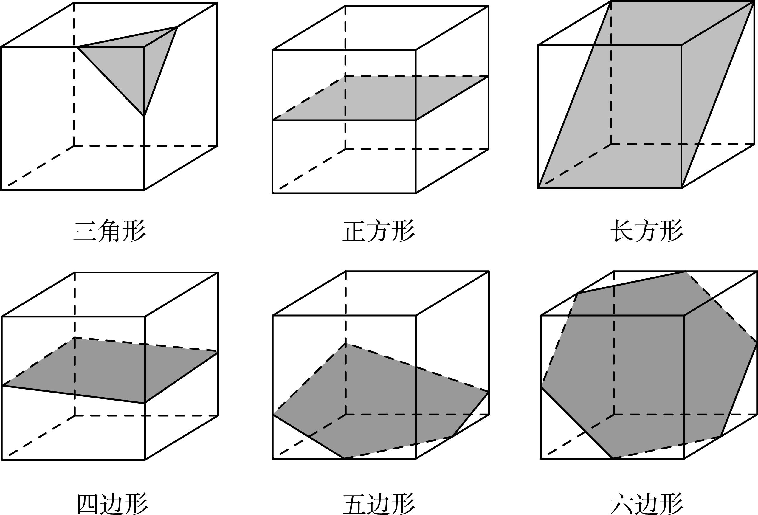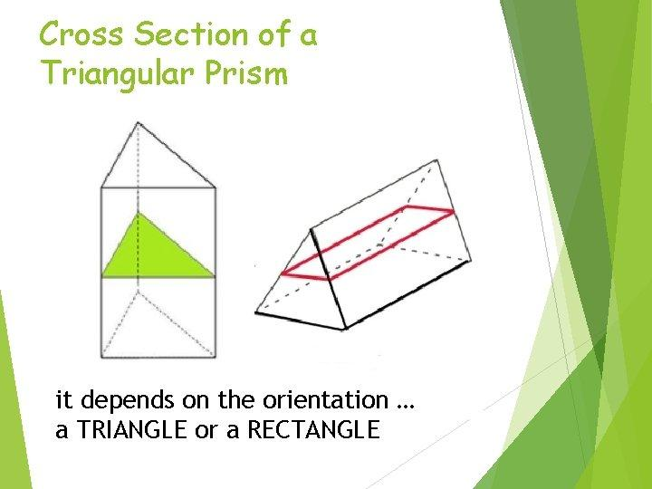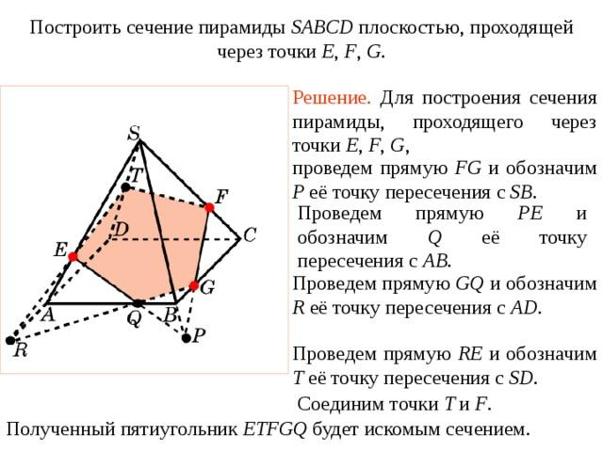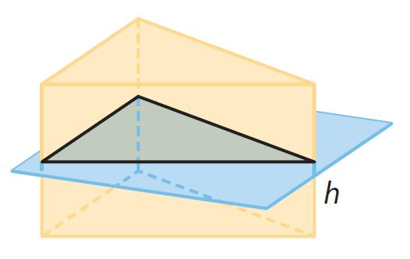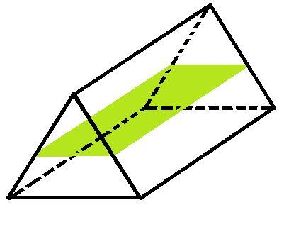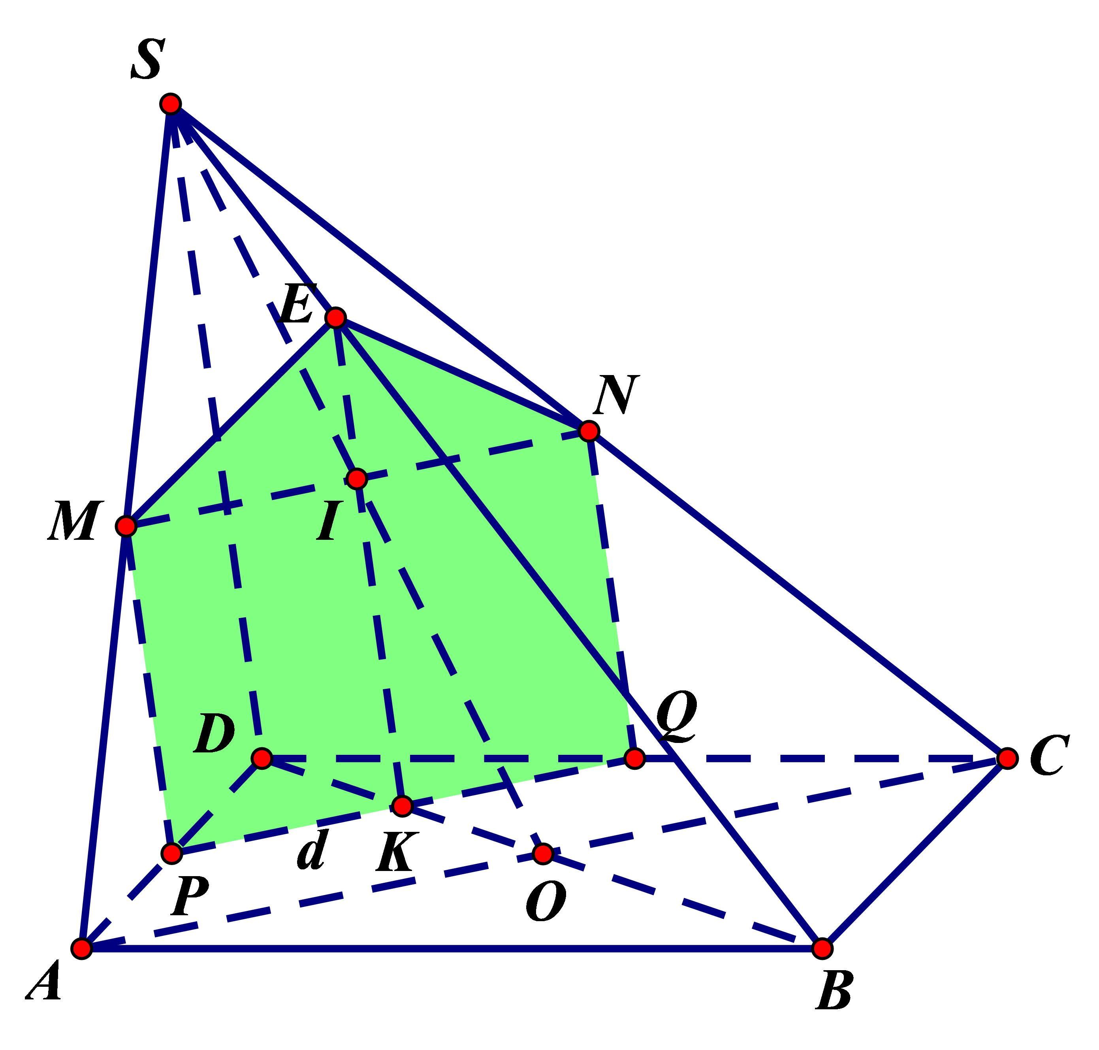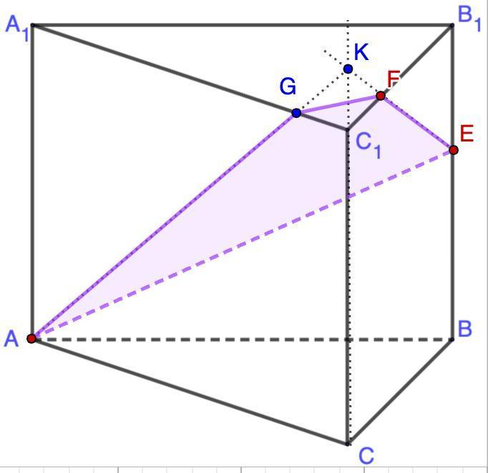

Geometric Structure
# Source: AI Source: Provided by: [Data Path: Persons Table -> ID Column: 1, Name_En Column: Motasem Essam] -> From: [ChatGPT] on [7/25/2026]
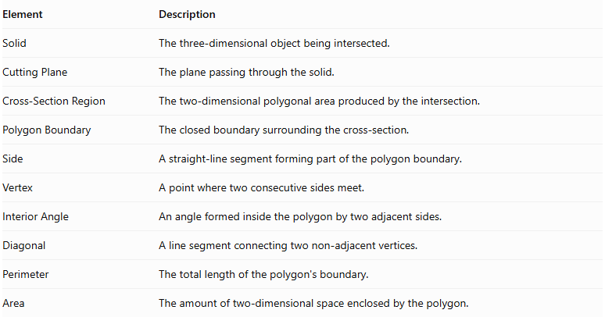
Element | Description
Solid | The three-dimensional object being intersected.
Cutting Plane | The plane passing through the solid.
Cross-Section Region | The two-dimensional polygonal area produced by the intersection.
Polygon Boundary | The closed boundary surrounding the cross-section.
Side | A straight-line segment forming part of the polygon boundary.
Vertex | A point where two consecutive sides meet.
Interior Angle | An angle formed inside the polygon by two adjacent sides.
Diagonal | A line segment connecting two non-adjacent vertices.
Perimeter | The total length of the polygon's boundary.
Area | The amount of two-dimensional space enclosed by the polygon.

Main Characteristics
# Source: AI Source: Provided by: [Data Path: Persons Table -> ID Column: 1, Name_En Column: Motasem Essam] -> From: [ChatGPT] on [7/25/2026]
- The cross section is a two-dimensional polygon.
- Its boundary consists of straight-line segments.
- It has at least three sides and three vertices.
- Its shape depends on the solid and the cutting plane.
- Each side generally lies along the intersection of the cutting plane with a face of the solid.
- The number of sides is related to the number of faces that the plane intersects.
- The polygon may be regular or irregular, convex or concave, depending on the solid and the section.
For a convex polyhedron, a plane section with a two-dimensional interior is a convex polygon.

Types of Polygonal Cross Sections
# Source: AI Source: Provided by: [Data Path: Persons Table -> ID Column: 1, Name_En Column: Motasem Essam] -> From: [ChatGPT] on [7/25/2026]
Polygonal cross sections can be classified according to the number of sides of the resulting polygon.

Triangular Cross Section
# Source: AI Source: Provided by: [Data Path: Persons Table -> ID Column: 1, Name_En Column: Motasem Essam] -> From: [ChatGPT] on [7/25/2026]
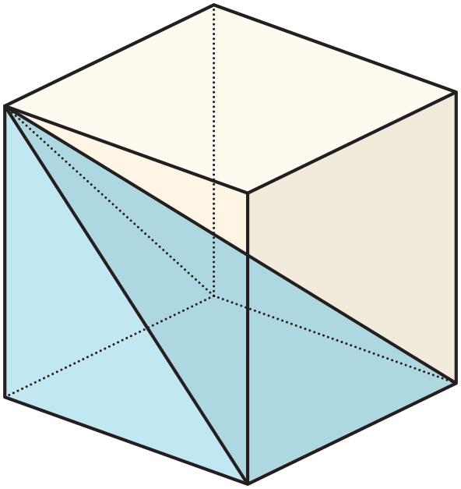
A triangular cross section is a polygonal section with three sides and three vertices.
- It can be formed by cutting a corner of a cube.
- It can occur in triangular prisms and pyramids.
- A plane passing through three suitable edges of a solid may produce a triangular section.

Quadrilateral Cross Section
# Source: AI Source: Provided by: [Data Path: Persons Table -> ID Column: 1, Name_En Column: Motasem Essam] -> From: [ChatGPT] on [7/25/2026]
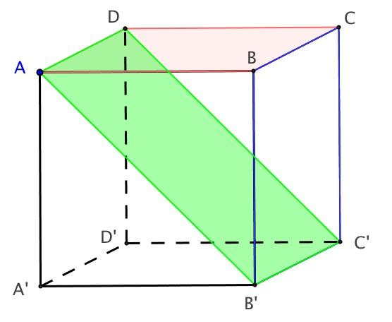
A quadrilateral cross section is a polygonal section with four sides and four vertices.
Possible shapes include:
- Square
- Rectangle
- Parallelogram
- Rhombus
- Trapezoid
- Irregular quadrilateral

Pentagonal Cross Section
# Source: AI Source: Provided by: [Data Path: Persons Table -> ID Column: 1, Name_En Column: Motasem Essam] -> From: [ChatGPT] on [7/25/2026]
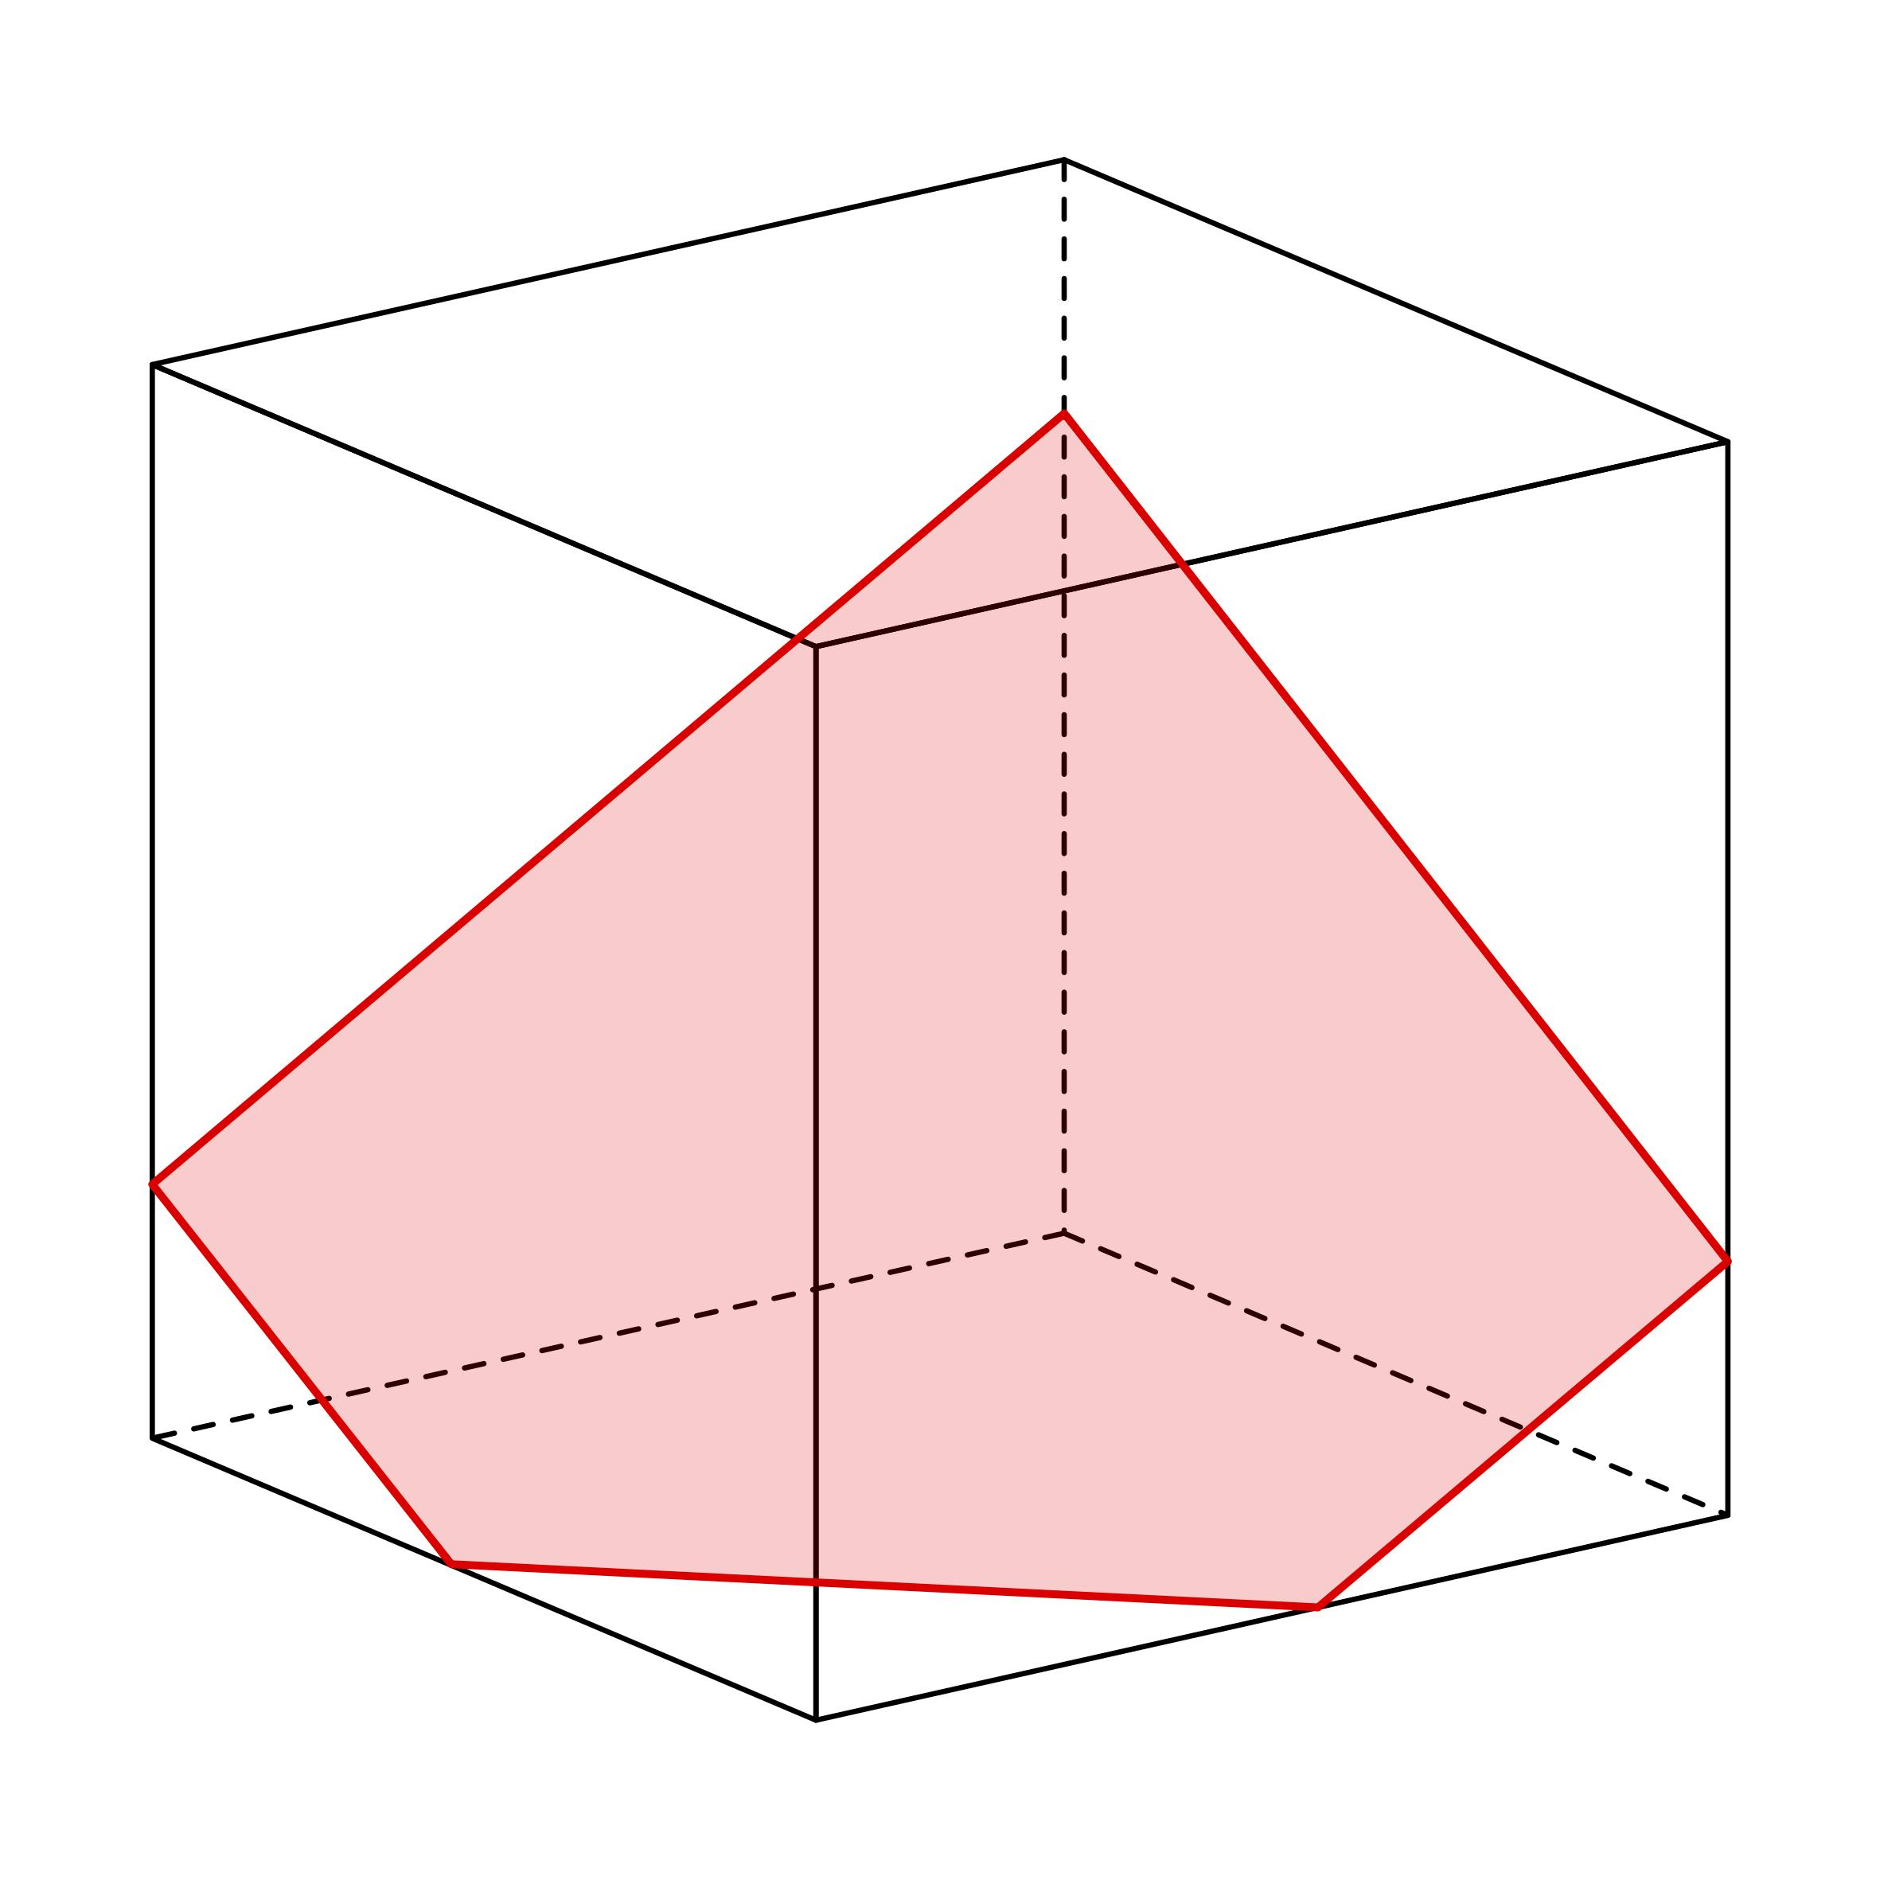
A pentagonal cross section is a polygonal section with five sides and five vertices.
It can be formed when the cutting plane intersects five boundary faces of a suitable polyhedron. A cube, for example, can produce a pentagonal cross section.

Hexagonal Cross Section
# Source: AI Source: Provided by: [Data Path: Persons Table -> ID Column: 1, Name_En Column: Motasem Essam] -> From: [ChatGPT] on [7/25/2026]
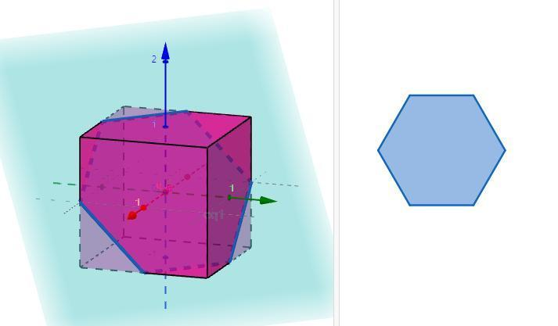
A hexagonal cross section is a polygonal section with six sides and six vertices.
- A cube can produce a hexagonal cross section when the plane intersects all six faces.
- The resulting hexagon may be regular or irregular.
- A regular hexagonal section is possible for a suitably oriented plane through a cube.

Heptagonal Cross Section
# Source: AI Source: Provided by: [Data Path: Persons Table -> ID Column: 1, Name_En Column: Motasem Essam] -> From: [ChatGPT] on [7/25/2026]
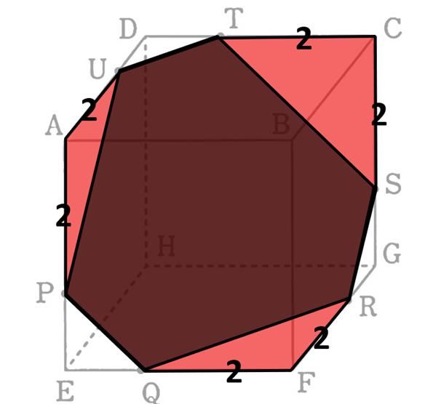
A heptagonal cross section is a polygonal section with seven sides and seven vertices.
It can occur in polyhedra with a sufficient number of faces when the cutting plane intersects seven of their faces.

Octagonal Cross Section
# Source: AI Source: Provided by: [Data Path: Persons Table -> ID Column: 1, Name_En Column: Motasem Essam] -> From: [ChatGPT] on [7/25/2026]
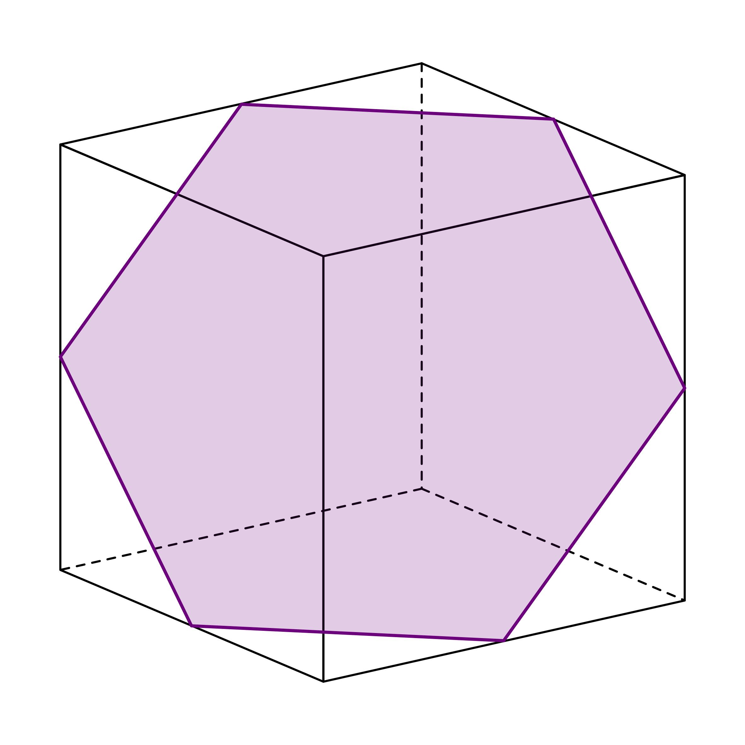
An octagonal cross section is a polygonal section with eight sides and eight vertices.
It can occur in suitable polyhedra with enough faces and an appropriate cutting-plane position.

Nonagonal Cross Section
# Source: AI Source: Provided by: [Data Path: Persons Table -> ID Column: 1, Name_En Column: Motasem Essam] -> From: [ChatGPT] on [7/25/2026]
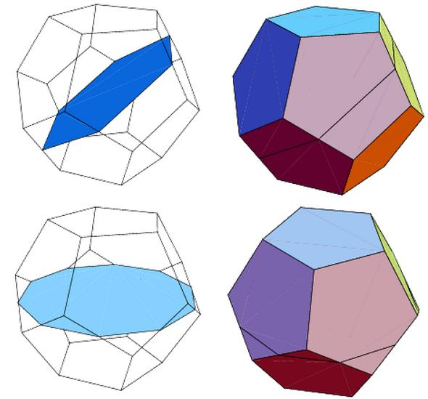
A nonagonal cross section is a polygonal section with nine sides and nine vertices.

Decagonal Cross Section
# Source: AI Source: Provided by: [Data Path: Persons Table -> ID Column: 1, Name_En Column: Motasem Essam] -> From: [ChatGPT] on [7/25/2026]
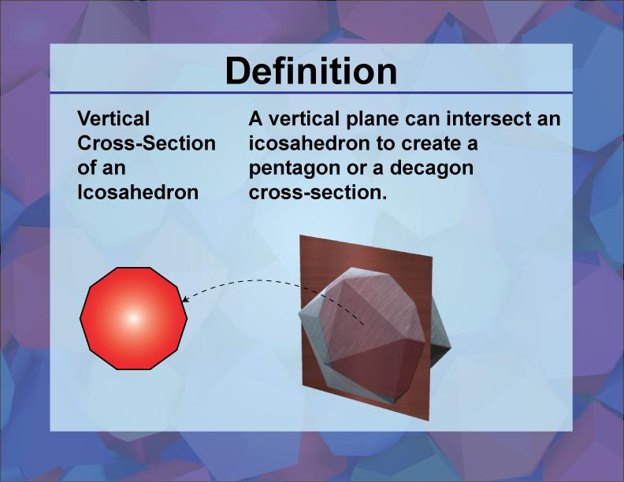
A decagonal cross section is a polygonal section with ten sides and ten vertices.

Cross Sections with More Than Ten Sides
# Source: AI Source: Provided by: [Data Path: Persons Table -> ID Column: 1, Name_En Column: Motasem Essam] -> From: [ChatGPT] on [7/25/2026]
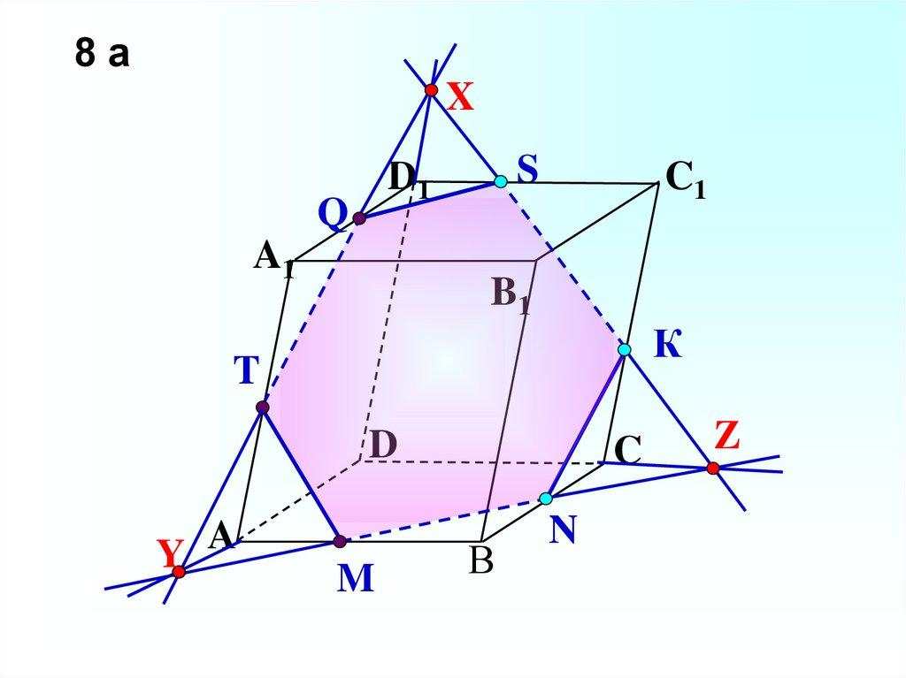
A polyhedron with a sufficiently large number of faces can produce cross sections with more than ten sides.
Examples include:
- Undecagonal Cross Section — 11 sides.
- Dodecagonal Cross Section — 12 sides.
- Tridecagonal Cross Section — 13 sides.
- Tetradecagonal Cross Section — 14 sides.
- Pentadecagonal Cross Section — 15 sides.
- And higher-sided polygonal cross sections.
Important: These are possible polygon types, not shapes that every polyhedron can produce. The solid must have enough suitable faces, and the plane must intersect them in the required arrangement.

Classification According to Polygon Properties
# Source: AI Source: Provided by: [Data Path: Persons Table -> ID Column: 1, Name_En Column: Motasem Essam] -> From: [ChatGPT] on [7/25/2026]
In addition to the number of sides, polygonal cross sections can be classified according to their geometric properties.

According to Regularity
# Source: AI Source: Provided by: [Data Path: Persons Table -> ID Column: 1, Name_En Column: Motasem Essam] -> From: [ChatGPT] on [7/25/2026]
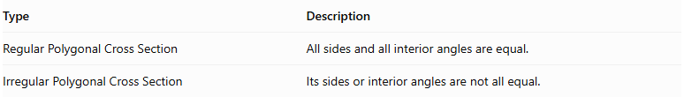
Type | Description
Regular Polygonal Cross Section | All sides and all interior angles are equal.
Irregular Polygonal Cross Section | Its sides or interior angles are not all equal.
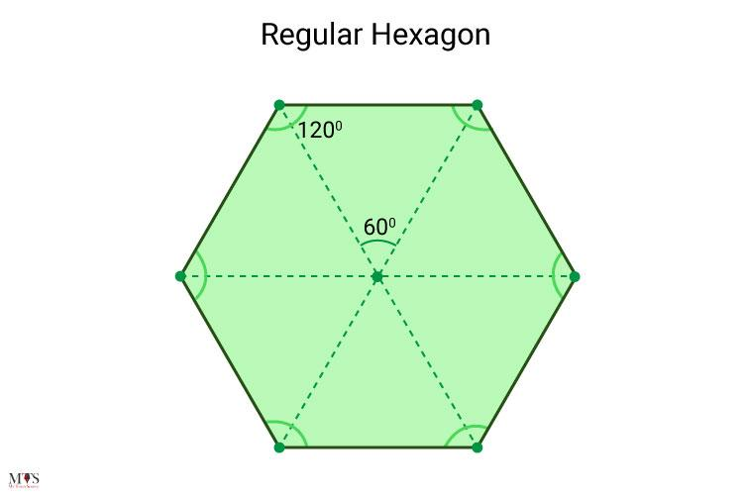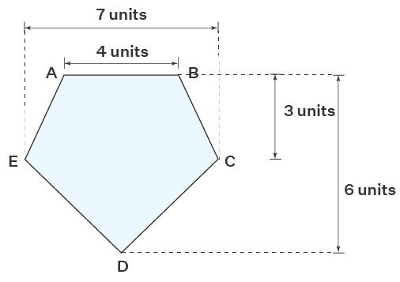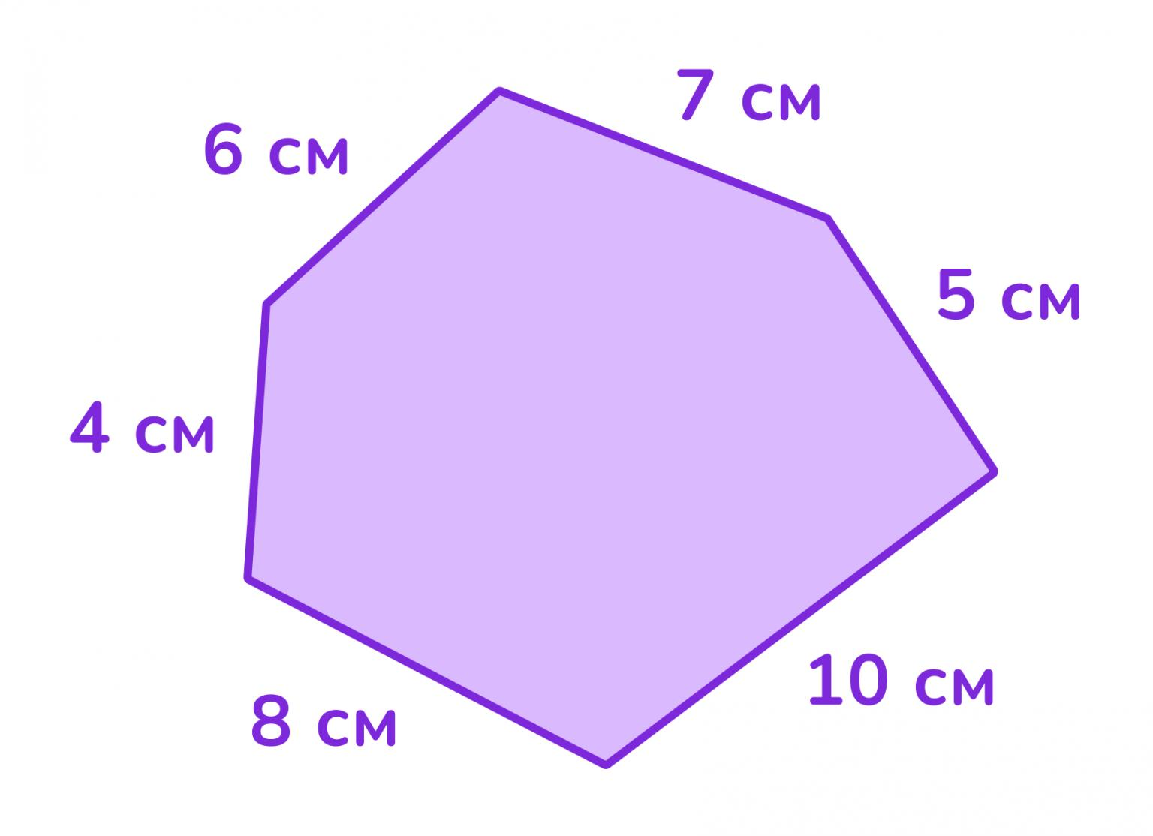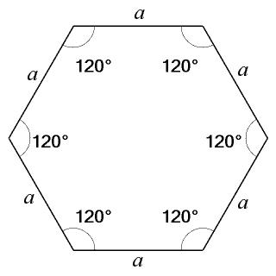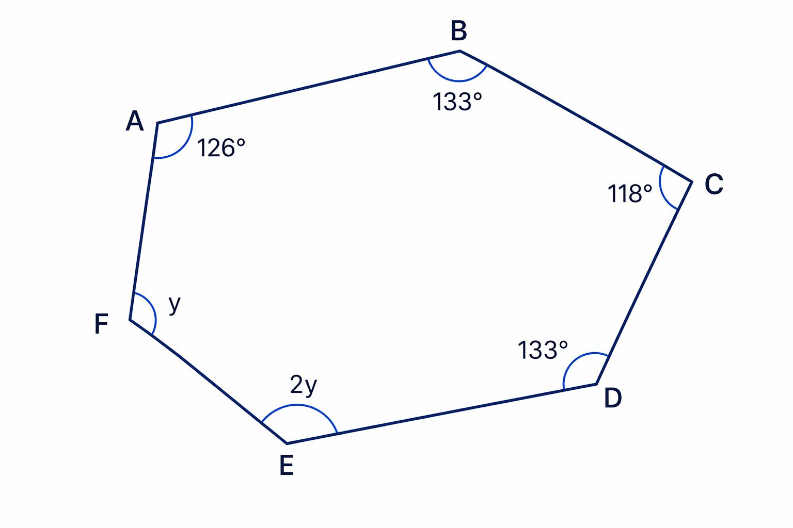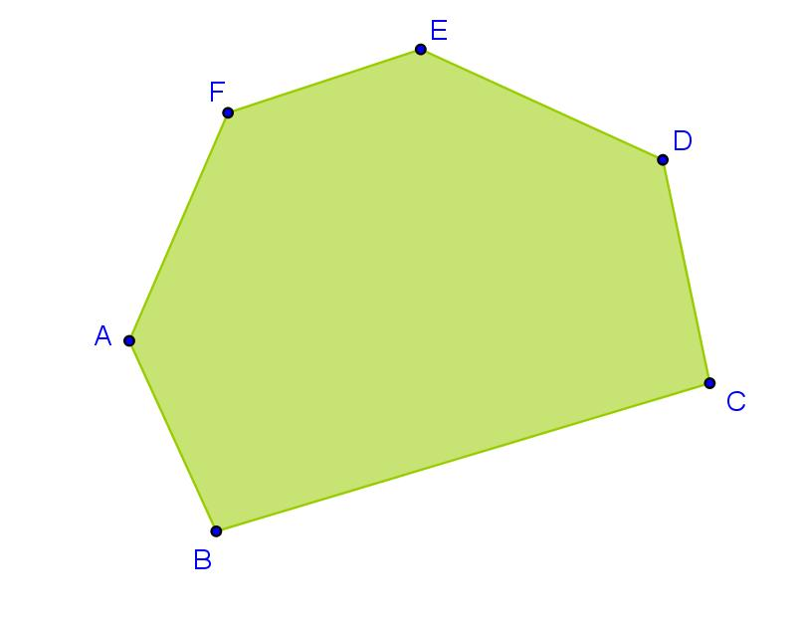

According to Convexity
# Source: AI Source: Provided by: [Data Path: Persons Table -> ID Column: 1, Name_En Column: Motasem Essam] -> From: [ChatGPT] on [7/25/2026]
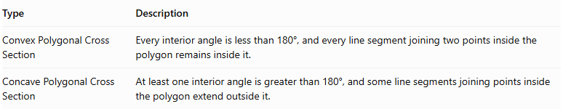
Type | Description
Convex Polygonal Cross Section | Every interior angle is less than 180°, and every line segment joining two points inside the polygon remains inside it.
Concave Polygonal Cross Section | At least one interior angle is greater than 180°, and some line segments joining points inside the polygon extend outside it.
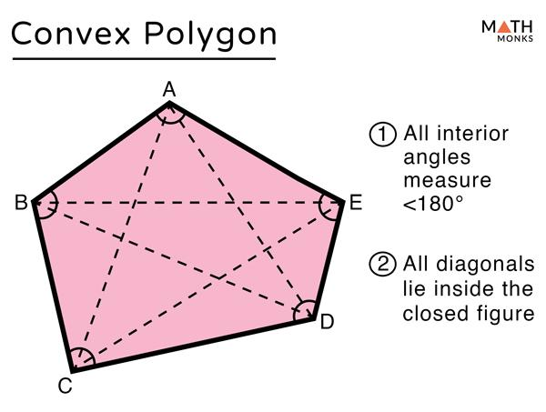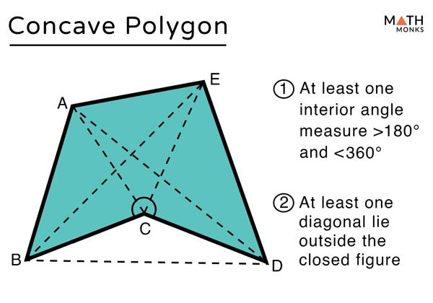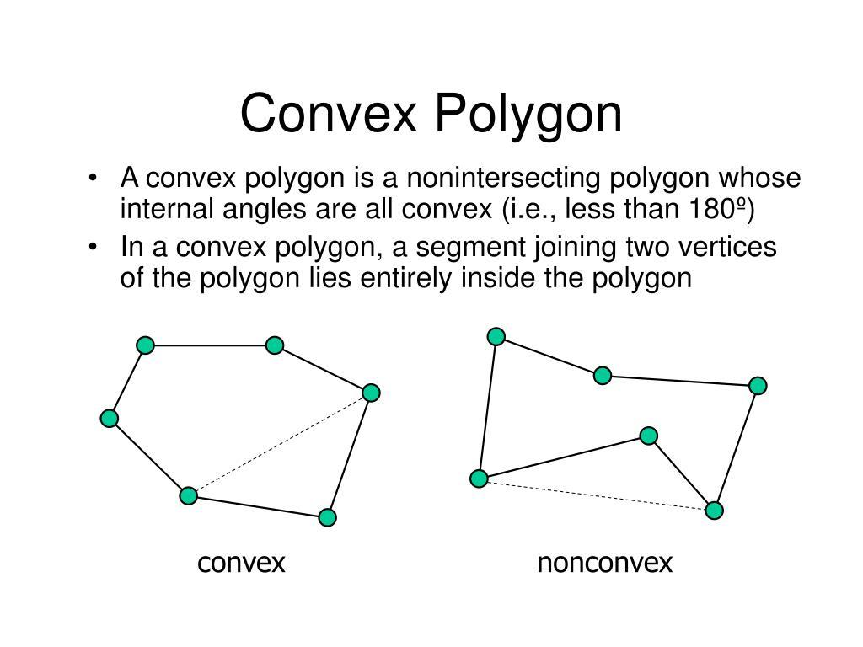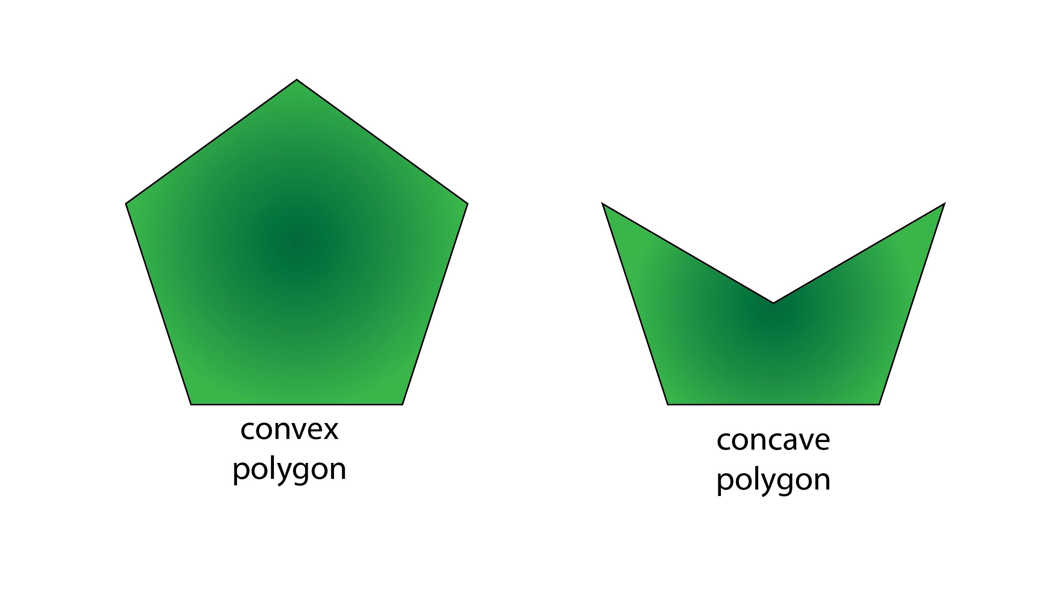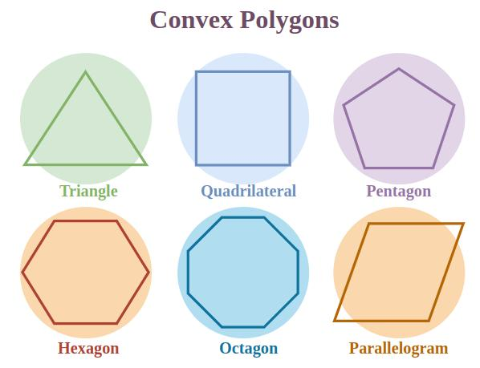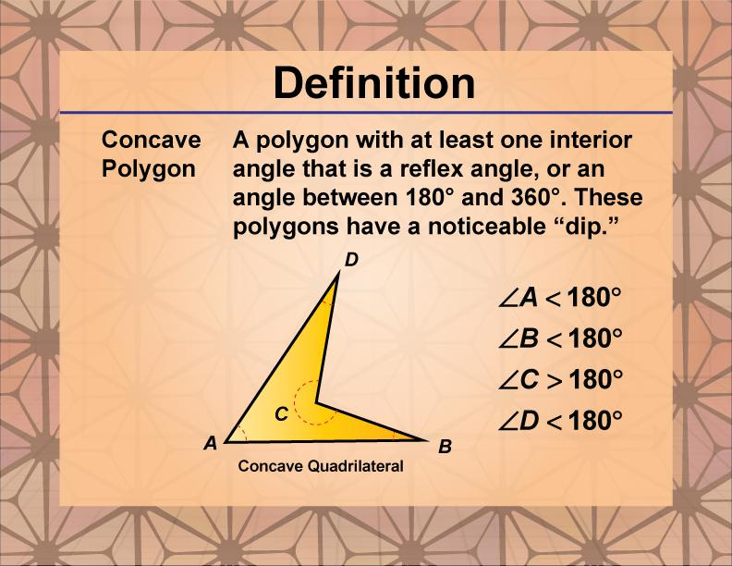
Note: A plane section of a convex solid must be convex. Concave polygonal sections can occur when the intersected solid itself is non-convex.

Examples According to Solid Type
# Source: AI Source: Provided by: [Data Path: Persons Table -> ID Column: 1, Name_En Column: Motasem Essam] -> From: [ChatGPT] on [7/25/2026]
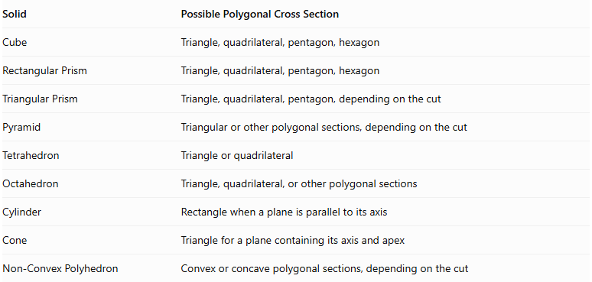
Solid | Possible Polygonal Cross Section
Cube | Triangle, quadrilateral, pentagon, hexagon
Rectangular Prism | Triangle, quadrilateral, pentagon, hexagon
Triangular Prism | Triangle, quadrilateral, pentagon, depending on the cut
Pyramid | Triangular or other polygonal sections, depending on the cut
Tetrahedron | Triangle or quadrilateral
Octahedron | Triangle, quadrilateral, or other polygonal sections
Cylinder | Rectangle when a plane is parallel to its axis
Cone | Triangle for a plane containing its axis and apex
Non-Convex Polyhedron | Convex or concave polygonal sections, depending on the cut

Mathematical Representation

Polygonal Cross-Section Boundary
# Source: AI Source: Provided by: [Data Path: Persons Table -> ID Column: 1, Name_En Column: Motasem Essam] -> From: [ChatGPT] on [7/25/2026]
A polygonal cross section can be represented by an ordered sequence of vertices:
$$P_{1},P_{2},P_{3},…,P_{n}$$
Where:
- $n$ is the number of vertices.
- Each consecutive pair of vertices forms a side.
- The final vertex connects back to the first vertex.
The number of sides is:
$$N_{\text{sides}}=n$$

Perimeter
# Source: AI Source: Provided by: [Data Path: Persons Table -> ID Column: 1, Name_En Column: Motasem Essam] -> From: [ChatGPT] on [7/25/2026]
The perimeter is the sum of all side lengths:
$$P=s_{1}+s_{2}+⋯+s_{n}$$

Area of a Regular Polygon
# Source: AI Source: Provided by: [Data Path: Persons Table -> ID Column: 1, Name_En Column: Motasem Essam] -> From: [ChatGPT] on [7/25/2026]
$$A=\frac{1}{2}ap$$
Where:
- $A$ = area.
- $a$ = apothem.
- $p$ = perimeter.
For a regular polygon with $n$ sides of length $s$:
$$A=\frac{{ns}^{2}}{4tan(π/n)}$$

Area of an Irregular Polygon
# Source: AI Source: Provided by: [Data Path: Persons Table -> ID Column: 1, Name_En Column: Motasem Essam] -> From: [ChatGPT] on [7/25/2026]
For vertices with coordinates $(x_{i},y_{i})$, the shoelace formula is:
$$A=\frac{1}{2}\left|\sum_{i=1}^{n}{(x_{i}y_{i+1}-x_{i+1}y_{i})}\right|$$
With the last vertex connected back to the first.

Interior Angle Sum
# Source: AI Source: Provided by: [Data Path: Persons Table -> ID Column: 1, Name_En Column: Motasem Essam] -> From: [ChatGPT] on [7/25/2026]
For a simple polygon with $n$ sides:
$$S=(n-2)×{180}^{∘}$$
For a regular polygon, each interior angle is:
$$θ=\frac{(n-2)×{180}^{∘}}{n}$$

Mathematical Properties
# Source: AI Source: Provided by: [Data Path: Persons Table -> ID Column: 1, Name_En Column: Motasem Essam] -> From: [ChatGPT] on [7/25/2026]
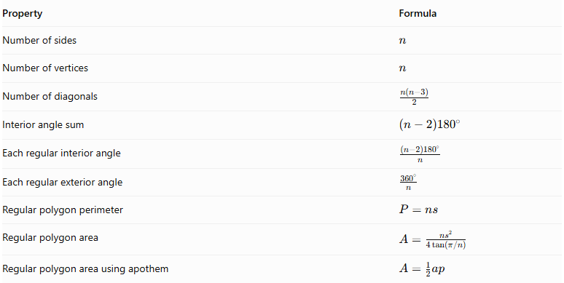
Property | Formula
Number of sides | $$n$$
Number of vertices | $$n$$
Number of diagonals | $$\frac{n(n-3)}{2}$$
Interior angle sum | $$(n-2){180}^{∘}$$
Each regular interior angle | $$\frac{(n-2){180}^{∘}}{n}$$
Each regular exterior angle | $$\frac{{360}^{∘}}{n}$$
Regular polygon perimeter | $$P=ns$$
Regular polygon area | $$A=\frac{{ns}^{2}}{4tan(π/n)}$$
Regular polygon area using apothem | $$A=\frac{1}{2}ap$$

Polygonal Cross Section vs. Other Cross-Section Shapes
# Source: AI Source: Provided by: [Data Path: Persons Table -> ID Column: 1, Name_En Column: Motasem Essam] -> From: [ChatGPT] on [7/25/2026]
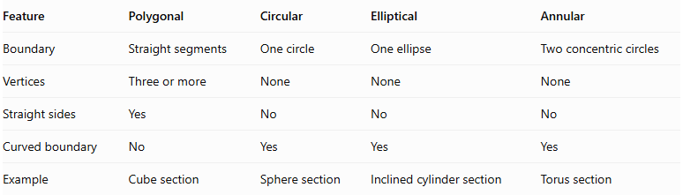
Feature | Polygonal | Circular | Elliptical | Annular
Boundary | Straight segments | One circle | One ellipse | Two concentric circles
Vertices | Three or more | None | None | None
Straight sides | Yes | No | No | No
Curved boundary | No | Yes | Yes | Yes
Example | Cube section | Sphere section | Inclined cylinder section | Torus section

Applications
# Source: AI Source: Provided by: [Data Path: Persons Table -> ID Column: 1, Name_En Column: Motasem Essam] -> From: [ChatGPT] on [7/25/2026]
- Architecture: Analyzing the polygonal profiles of structural components.
- Engineering: Studying the internal sections of mechanical parts.
- Manufacturing: Determining the shape of a component after cutting.
- Mathematics: Studying polygons, plane intersections, and polyhedral geometry.
- Computer Graphics: Generating polygonal meshes and representing sections of 3D models.
- Technical Drawing: Showing the shape of a solid after an imaginary cutting plane passes through it.

Main Classification
# Source: AI Source: Provided by: [Data Path: Persons Table -> ID Column: 1, Name_En Column: Motasem Essam] -> From: [ChatGPT] on [7/25/2026]
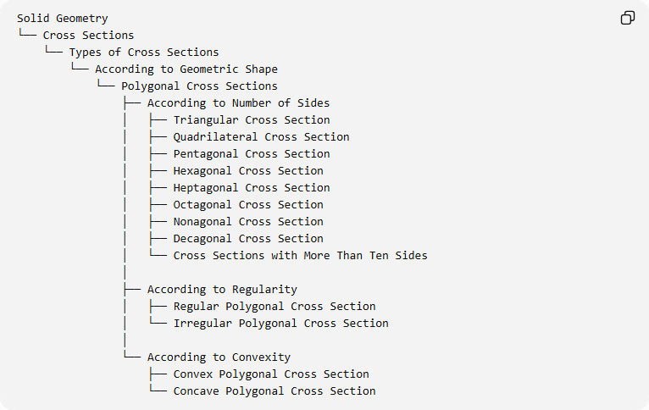
Solid Geometry
└── Cross Sections
└── Types of Cross Sections
└── According to Geometric Shape
└── Polygonal Cross Sections
├── According to Number of Sides
│ ├── Triangular Cross Section
│ ├── Quadrilateral Cross Section
│ ├── Pentagonal Cross Section
│ ├── Hexagonal Cross Section
│ ├── Heptagonal Cross Section
│ ├── Octagonal Cross Section
│ ├── Nonagonal Cross Section
│ ├── Decagonal Cross Section
│ └── Cross Sections with More Than Ten Sides
│
├── According to Regularity
│ ├── Regular Polygonal Cross Section
│ └── Irregular Polygonal Cross Section
│
└── According to Convexity
├── Convex Polygonal Cross Section
└── Concave Polygonal Cross Section

Key Points
# Source: AI Source: Provided by: [Data Path: Persons Table -> ID Column: 1, Name_En Column: Motasem Essam] -> From: [ChatGPT] on [7/25/2026]
- A polygonal cross section is a two-dimensional region bounded by straight-line segments.
- Its shape depends on the solid and the cutting plane.
- Polygonal cross sections can have three or more sides.
- A cube can produce triangular, quadrilateral, pentagonal, and hexagonal sections.
- Polygonal cross sections can be regular or irregular.
- They can be convex or concave, although sections of convex solids are necessarily convex.
- The area and perimeter depend on the dimensions of the resulting polygon.

Conclusion
# Source: AI Source: Provided by: [Data Path: Persons Table -> ID Column: 1, Name_En Column: Motasem Essam] -> From: [ChatGPT] on [7/25/2026]
Polygonal Cross Sections are plane intersections that produce polygonal regions with straight sides and vertices. They are classified by their number of sides, regularity, and convexity. They are especially important in the study of polyhedra, prisms, pyramids, and geometric modeling.

